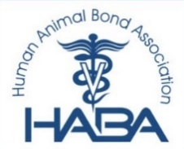
Human Animal Bond Association Student Scholarship APPLICATION

Personal Information
[ ] Currently enrolled and in good academic standing at an AVMA
accredited Veterinary College / School (Please Check)

NAME: _________________________________ _______________________ _____
Last First M.I.
ADDRESS: _____________________________________________________
Number and Street Address / P.O Box / C/O
_____________________________________________________
Apartment Number / Building/ Suite / Unit / Floor / Etc.
_______________________________ _________________________________
City State / Province /Region
_______________________________ _________________________________
Zip Code / Postal Code Country
Email: _________________________________________________

Telephone:__________________________________________________
(including area code)
__________________________________________________
College / School of Veterinary Medicine
__________ ______________________ _____________________
Current GPA Graduation: Month / Year Date of HABA Membership

ESSAY:

